**DAILY ONLINE ACTIVITIES SUMMARY**

|  |  |  |  |  |  |  |  |  |
| --- | --- | --- | --- | --- | --- | --- | --- | --- |
| **Date:** | **03-06-2020** | | | | | **Name:** | **Ajeyashree K** | |
| **Sem & Sec** | **6th&A** | | | | | **USN:** | **4AL17CS002** | |
| **Online Test Summary** | | | | | | | | |
| **Subject** | | **Python Application Programming.** | | | | | | |
| **Max. Marks** | | **20** | | **Score** | | | **13** | |
| **Certification Course Summary** | | | | | | | | |
| **Course** | **INTRODUCTION TO CLOUD** | | | | | | | |
| **Certificate Provider** | | | COGNITIVE  CLASS IBM. | | **Duration** | | | 14hours |
| **Coding Challenges** | | | | | | | | |
| **Problem Statement:** 1. Take a list of length 3 containing integers, find out which is larger, first or last one and set all the elements in the list to be that value.  2. Write a python program to generate prime number in an interval.  3. Write a Java Program to Implement Circular Doubly Linked List. | | | | | | | | |
| **Status: Done** | | | | | | | | |
| **Uploaded the report in Github** | | | | | **YES** | | | |
| **If yes Repository name** | | | | | <https://github.com/Ajeyashree/19-5-2020-online-coding-activity> | | | |
| **Uploaded the report in slack** | | | | | **YES** | | | |

Online Test Details:

Subject:- **Python Application Programming.**



Certification Course Details:

**Introduction to Cloud:**

Today I have taken exam and got certificate from IBM.

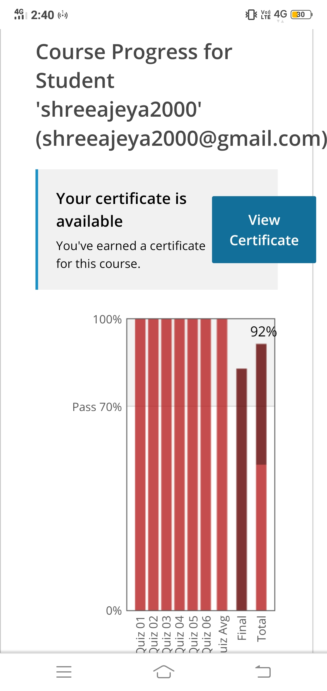





Coding Challenges Details:

1. Python Program

Problem statement:  
Take a list of length 3 containing integers, find out which is larger, first or last one and set all the elements in the list to be that value. Print the updated list  
eg:  
1)Input - Given list: [1, 2, 3]  
Output- [3,3,3]  
2)Input - Given list: [2, 11, 3]  
Output- [3,3,3]

lst=[]

n = int(input("Enter number of elements : "))

for i in range(0, n):

ele = int(input())

lst.append(3)

print(lst)

**output:**

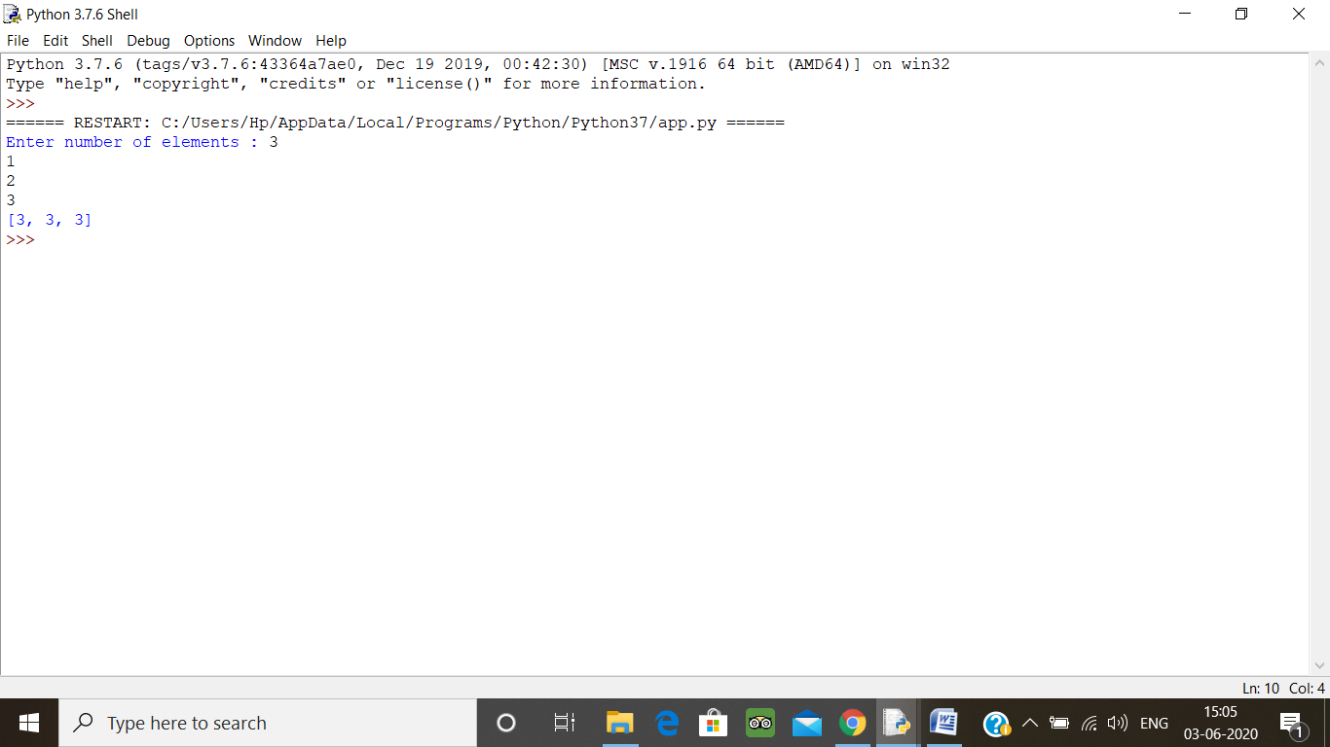

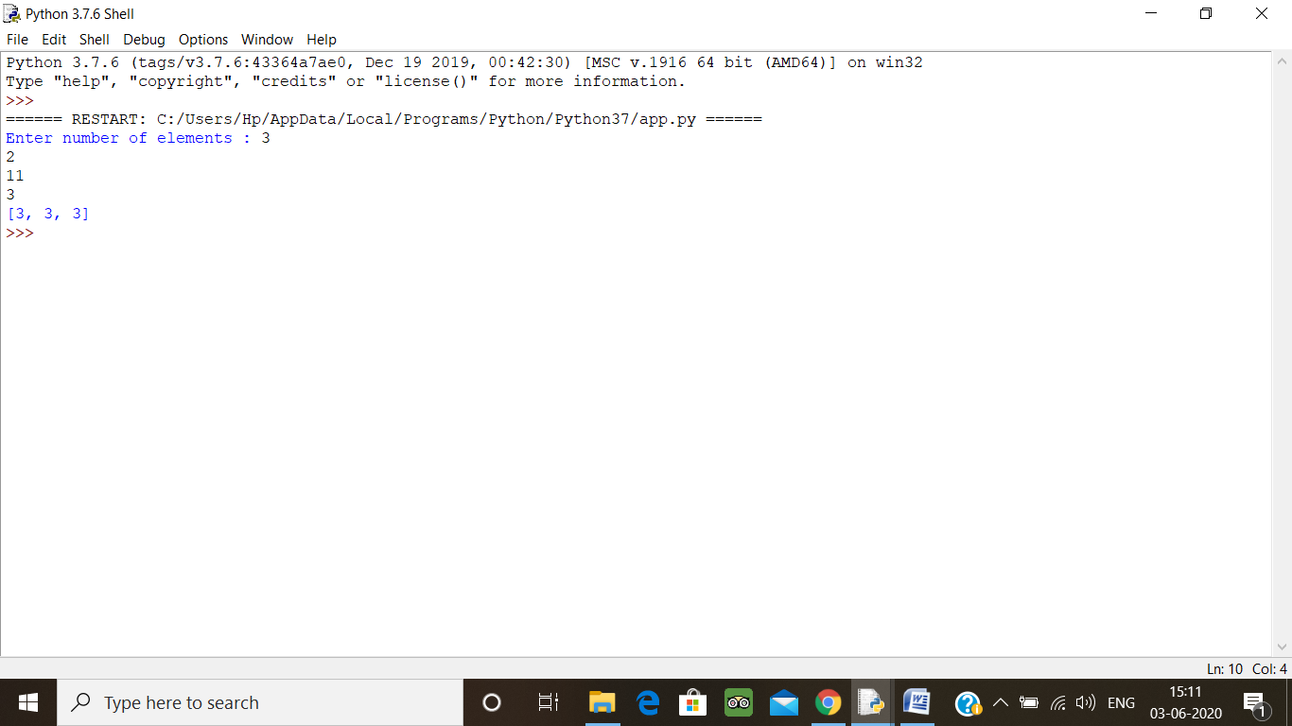

2. Write a python program to generate prime number in an interval

You just need to take two number as input from stdin and you need to find prime numbers between those two numbers and print them.

Input Format  
You will be taking two numbers as an input from stdin one on each line respectively.

Constraints  
1 <= A, B <= 10^4

Output Format  
You need to print the prime numbers one on each line

sample example:  
Input  
900  
1000  
Output  
907  
911  
919  
929  
937  
941  
947  
953  
967  
971  
977  
983  
991  
997

lower = int(input("Enter lower range: "))

upper = int(input("Enter upper range: "))

for num in range(lower,upper + 1):

if num > 1:

for i in range(2,num):

if (num % i) == 0:

break

else:

print(num)

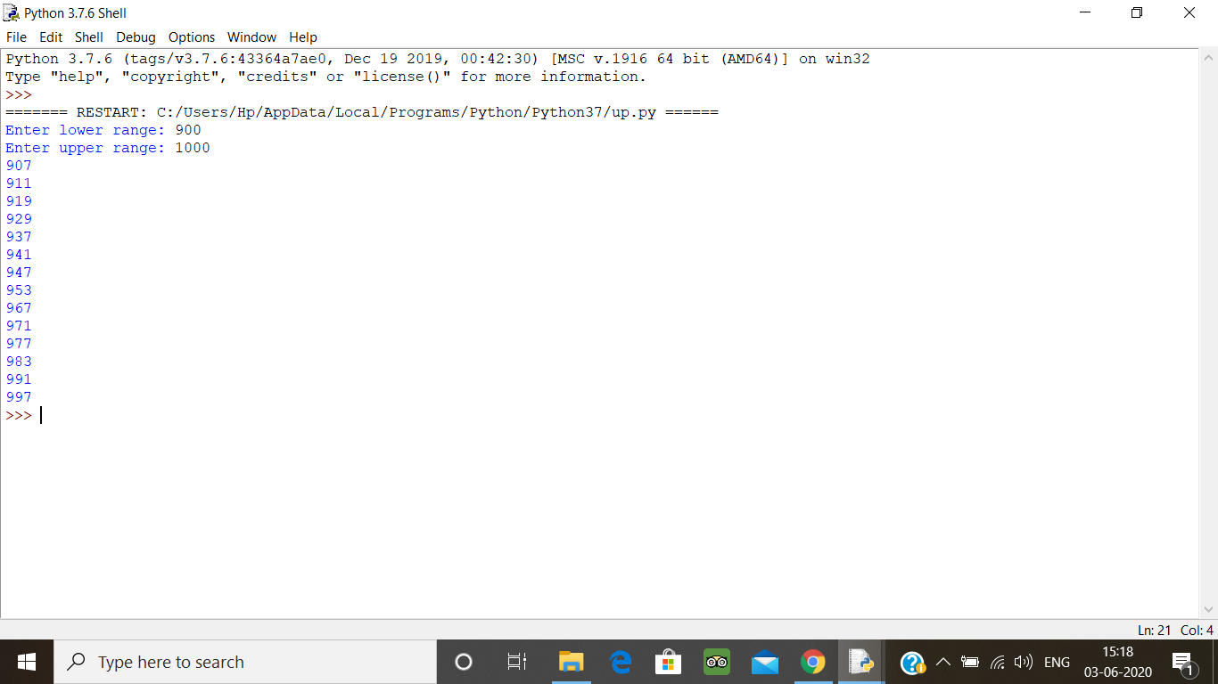

3. Write a Java Program to Implement Circular Doubly Linked List

import java.util.Scanner;

class Node

{

protected int data;

protected Node next, prev;

public Node()

{

next = null;

prev = null;

data = 0;

}

/* Constructor */

public Node(int d, Node n, Node p)

{

data = d;

next = n;

prev = p;

}

/* Function to set link to next node */

public void setLinkNext(Node n)

{

next = n;

}

/* Function to set link to previous node */

public void setLinkPrev(Node p)

{

prev = p;

}

/* Funtion to get link to next node */

public Node getLinkNext()

{

return next;

}

/* Function to get link to previous node */

public Node getLinkPrev()

{

return prev;

}

/* Function to set data to node */

public void setData(int d)

{

data = d;

}

/* Function to get data from node */

public int getData()

{

return data;

}

}

/* Class linkedList */

class linkedList

{

protected Node start;

protected Node end ;

public int size;

/* Constructor */

public linkedList()

{

start = null;

end = null;

size = 0;

}

/* Function to check if list is empty */

public boolean isEmpty()

{

return start == null;

}

/* Function to get size of list */

public int getSize()

{

return size;

}

/* Function to insert element at begining */

public void insertAtStart(int val)

{

Node nptr = new Node(val, null, null);

if (start == null)

{

nptr.setLinkNext(nptr);

nptr.setLinkPrev(nptr);

start = nptr;

end = start;

}

else

{

nptr.setLinkPrev(end);

end.setLinkNext(nptr);

start.setLinkPrev(nptr);

nptr.setLinkNext(start);

start = nptr;

}

size++ ;

}

/*Function to insert element at end */

public void insertAtEnd(int val)

{

Node nptr = new Node(val, null, null);

if (start == null)

{

nptr.setLinkNext(nptr);

nptr.setLinkPrev(nptr);

start = nptr;

end = start;

}

else

{

nptr.setLinkPrev(end);

end.setLinkNext(nptr);

start.setLinkPrev(nptr);

nptr.setLinkNext(start);

end = nptr;

}

size++;

}

/* Function to insert element at position */

public void insertAtPos(int val, int pos)

{

Node nptr = new Node(val, null, null);

if (pos == 1)

{

insertAtStart(val);

return;

}

Node ptr = start;

for (int i = 2; i <= size; i++)

{

if (i == pos)

{

Node tmp = ptr.getLinkNext();

ptr.setLinkNext(nptr);

nptr.setLinkPrev(ptr);

nptr.setLinkNext(tmp);

tmp.setLinkPrev(nptr);

}

ptr = ptr.getLinkNext();

}

size++ ;

}

/* Function to delete node at position */

public void deleteAtPos(int pos)

{

if (pos == 1)

{

if (size == 1)

{

start = null;

end = null;

size = 0;

return;

}

start = start.getLinkNext();

start.setLinkPrev(end);

end.setLinkNext(start);

size--;

return ;

}

if (pos == size)

{

end = end.getLinkPrev();

end.setLinkNext(start);

start.setLinkPrev(end);

size-- ;

}

Node ptr = start.getLinkNext();

for (int i = 2; i <= size; i++)

{

if (i == pos)

{

Node p = ptr.getLinkPrev();

Node n = ptr.getLinkNext();

p.setLinkNext(n);

n.setLinkPrev(p);

size-- ;

return;

}

ptr = ptr.getLinkNext();

}

}

/* Function to display status of list */

public void display()

{

System.out.print("\nCircular Doubly Linked List = ");

Node ptr = start;

if (size == 0)

{

System.out.print("empty\n");

return;

}

if (start.getLinkNext() == start)

{

System.out.print(start.getData()+ " <-> "+ptr.getData()+ "\n");

return;

}

System.out.print(start.getData()+ " <-> ");

ptr = start.getLinkNext();

while (ptr.getLinkNext() != start)

{

System.out.print(ptr.getData()+ " <-> ");

ptr = ptr.getLinkNext();

}

System.out.print(ptr.getData()+ " <-> ");

ptr = ptr.getLinkNext();

System.out.print(ptr.getData()+ "\n");

}

}

/* Class CircularDoublyLinkedList */

public class Main

{

public static void main(String[] args)

{

Scanner scan = new Scanner(System.in);

/* Creating object of linkedList */

linkedList list = new linkedList();

System.out.println("Circular Doubly Linked List Test\n");

char ch;

/* Perform list operations */

do

{

System.out.println("\nCircular Doubly Linked List Operations\n");

System.out.println("1. insert at begining");

System.out.println("2. insert at end");

System.out.println("3. insert at position");

System.out.println("4. delete at position");

System.out.println("5. check empty");

System.out.println("6. get size");

int choice = scan.nextInt();

switch (choice)

{

case 1 :

System.out.println("Enter integer element to insert");

list.insertAtStart( scan.nextInt() );

break;

case 2 :

System.out.println("Enter integer element to insert");

list.insertAtEnd( scan.nextInt() );

break;

case 3 :

System.out.println("Enter integer element to insert");

int num = scan.nextInt() ;

System.out.println("Enter position");

int pos = scan.nextInt() ;

if (pos < 1 || pos > list.getSize() )

System.out.println("Invalid position\n");

else

list.insertAtPos(num, pos);

break;

case 4 :

System.out.println("Enter position");

int p = scan.nextInt() ;

if (p < 1 || p > list.getSize() )

System.out.println("Invalid position\n");

else

list.deleteAtPos(p);

break;

case 5 :

System.out.println("Empty status = "+ list.isEmpty());

break;

case 6 :

System.out.println("Size = "+ list.getSize() +"\n");

break;

default :

System.out.println("Wrong Entry\n ");

break;

}

/* Display List */

list.display();

System.out.println("\nDo you want to continue (Type y or n)\n");

ch = scan.next().charAt(0);

}

while (ch == 'Y'|| ch == 'y');

}

}

**Output:**

